SEASONAL AGRICULTURE PERFORMANCE ANALYSIS

Student Name : SIRDESAI AKSHITHA
College Name : St.JOHNS COLLEGE OF ENGINEERING & TECHNOLOGY AICTE STU ID : STU68ff572446c8a1761564452

1
9/8/2026 Annual Review

PROBLEM STATEMENT


- Agricultural activities are influenced by seasonal variations in environmental conditions, farming practices, resource availability and market conditions. As a result, agricultural performance may differ from one season to another.

- However, raw agricultural data does not clearly explain how agricultural performance changes across seasons or what patterns can be observed in different seasonal conditions.

- The problem is to analyze the given agricultural dataset and investigate seasonal differences in agricultural performance by identifying meaningful patterns, trends, relationships and variations within the available data.

2
9/8/2026 Annual Review

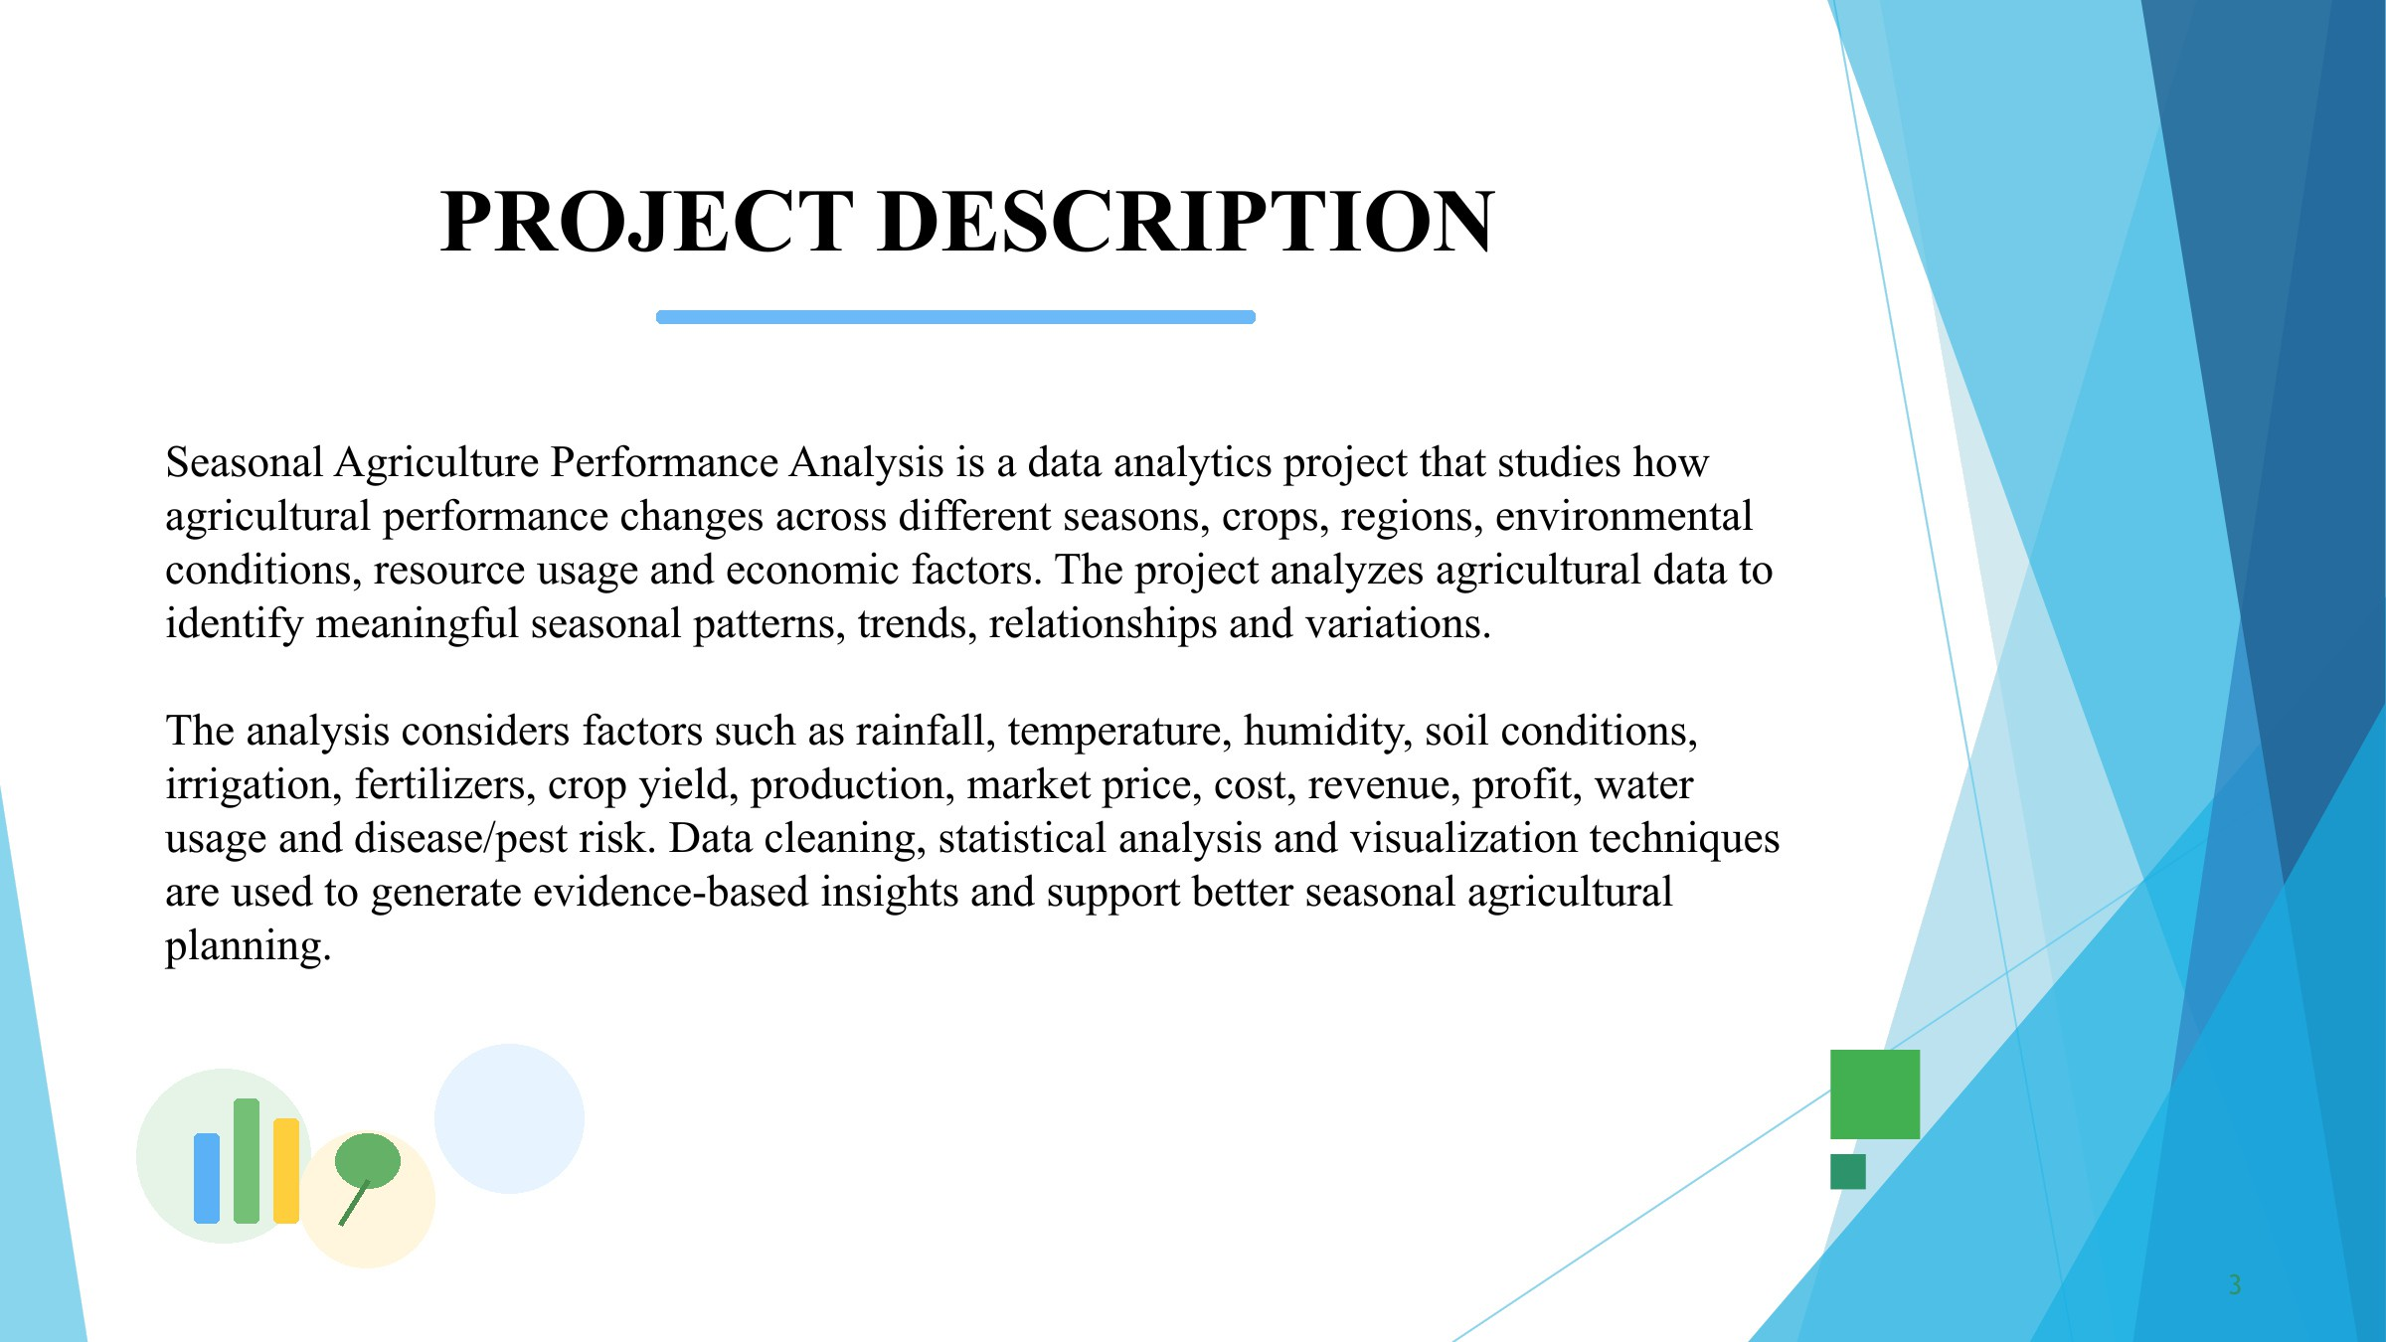

WHO ARE THE END USERS?

Farmers - To understand seasonal crop performance and improve farming decisions.

Agricultural Officers - To analyze seasonal agricultural conditions and provide guidance.
Agricultural Planners & Government Departments - To support evidence-based agricultural planning.
Researchers & Data Analysts - To study seasonal trends and relationships in agricultural data.
Agricultural Organizations - To compare crop performance, resource usage and economic outcomes.


4

9/8/2026 Annual Review

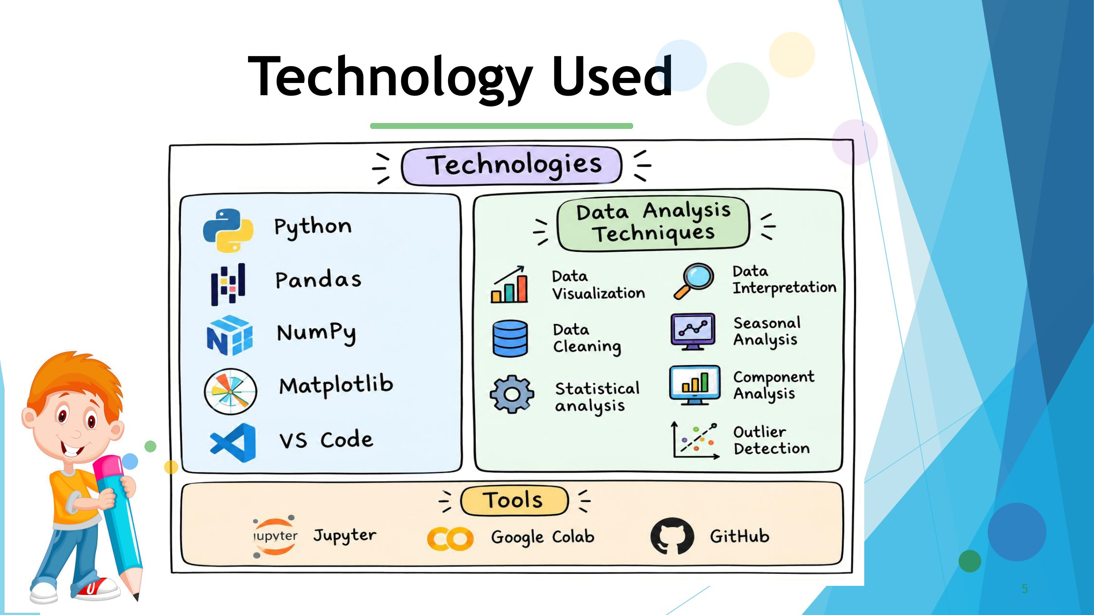

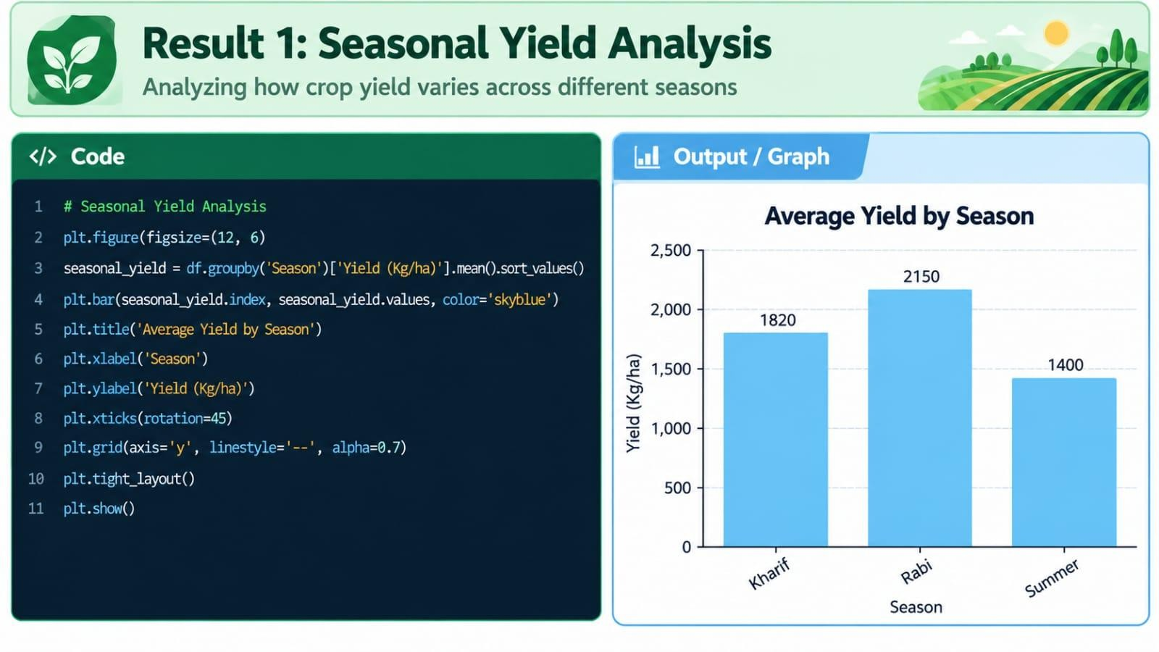
RESULTS

6
9/8/2026 Annual Review

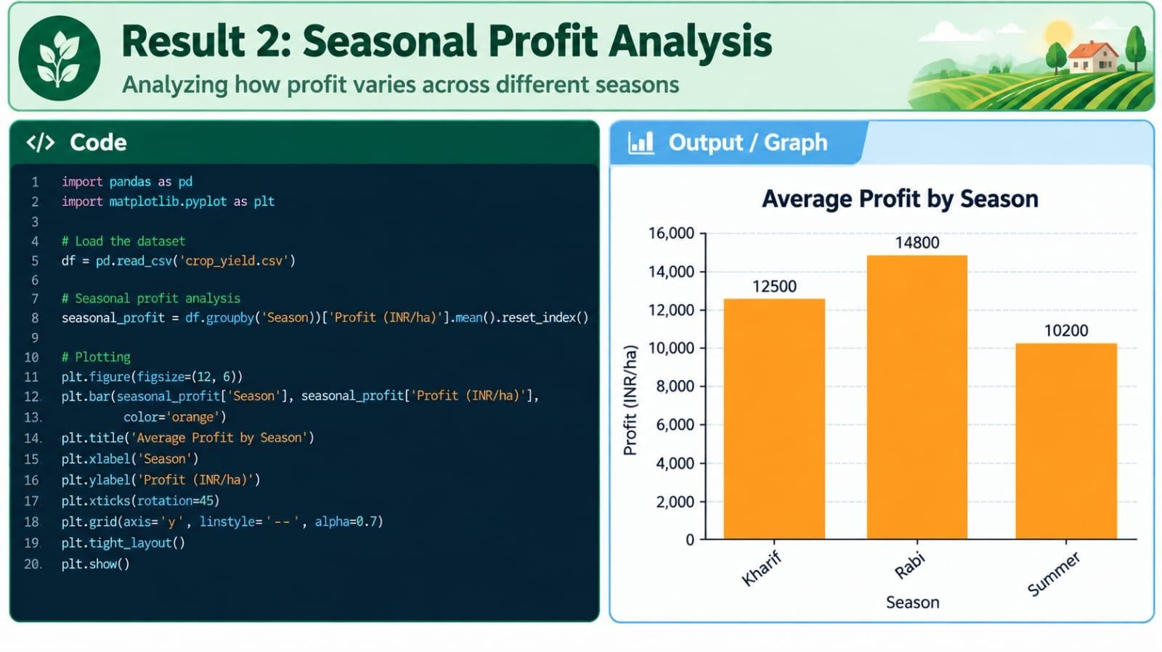
[Add screen shots of your code ]

7
9/8/2026 Annual Review

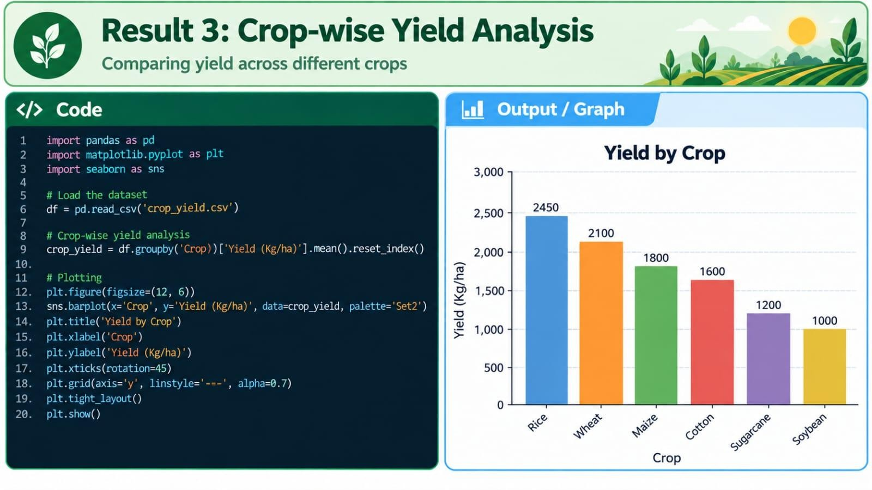
your code ]

c

8
9/8/2026 Annual Review

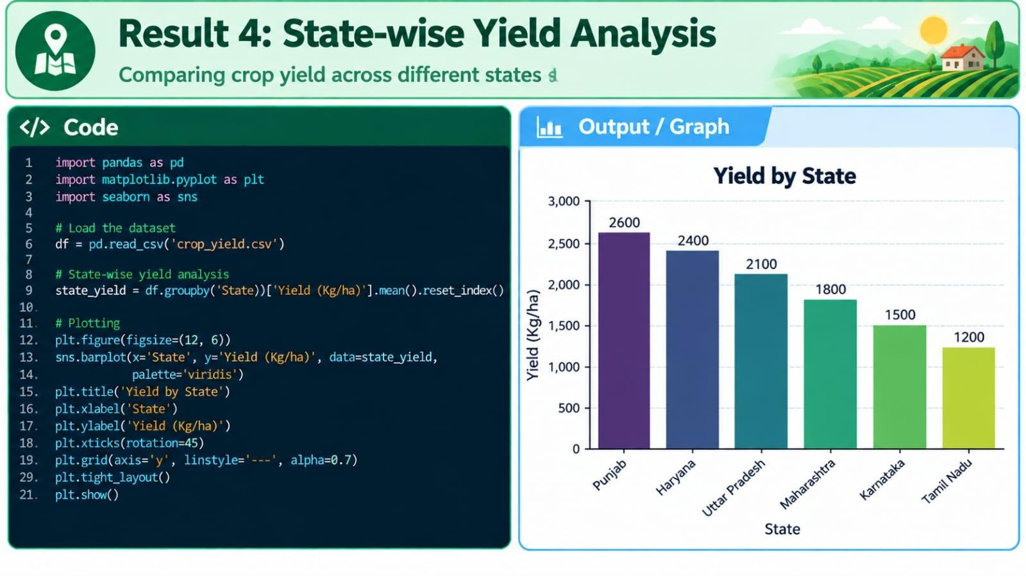
R

9
9/8/2026 Annual Review

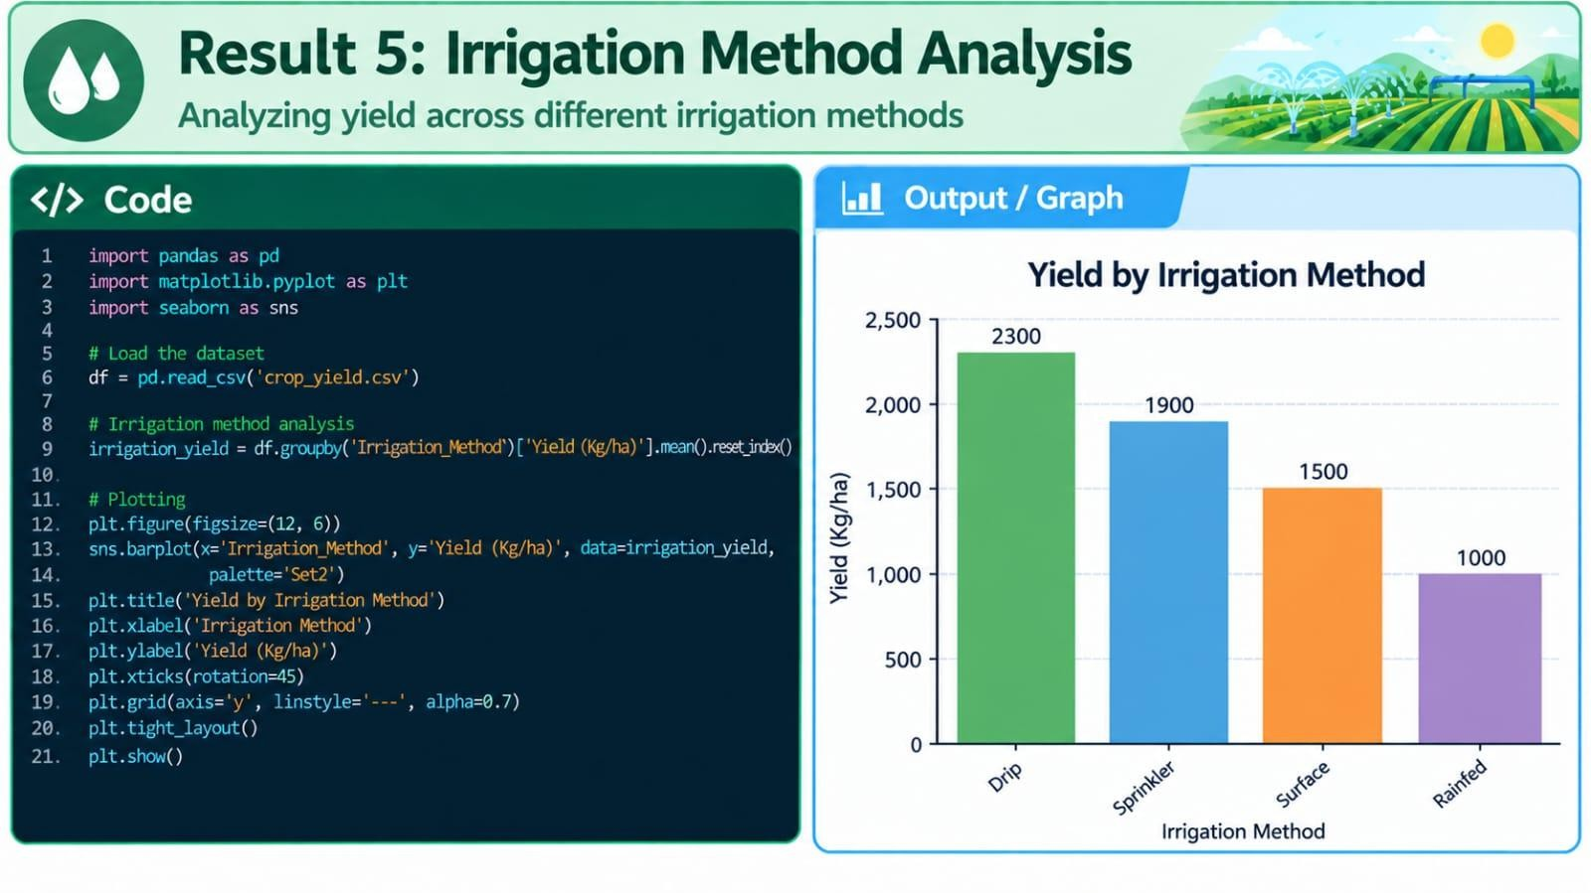
r

10
9/8/2026 Annual Review

FUTURE SCOPE
Real-time Agricultural Data: Integrate live weather, rainfall, temperature and soil data for continuous monitoring.

Crop Yield Prediction: Use Machine Learning models to predict crop yield for different seasons.

Weather-based Recommendations: Provide suitable crop and farming recommendations based on seasonal weather conditions.

Smart Irrigation: Develop intelligent irrigation recommendations to improve water efficiency.

Mobile Application: Extend the analysis into a mobile application for easy access by farmers.

11
9/8/2026 Annual Review

GitHub Link

https://github.com/akshithasd18/Seasonal-Agriculture-Performance-Analysis/tree/main

12
9/8/2026 Annual Review

VOIS Course completion certificate Course name- Data Visualization

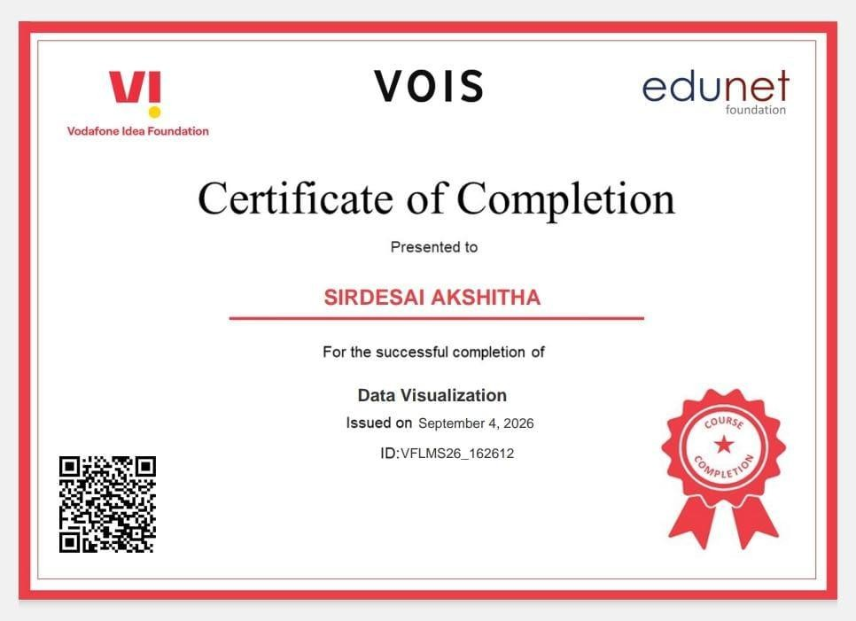
13
9/8/2026 Annual Review


THANK YOU

. .

14
9/8/2026 Annual Review

